**Instructions to use MQE-Details**

1. **For Column ‘TimeSpent’ in Date-wise sheets(1st Jun, 2nd Jun...):**

* **Inputs:**

1. **Column A (CH ID):** The CH-ID of the working user needs to be filled.
2. **Column C (Login Time):** - The Login Time of the user needs to be filled here.
3. **Column H (Status):** - The status of the specific question needs to be filled in this dropdown.

* **Output:** The moment you select a dropdown in the **Column-H**, the **TimeSpent** (**Column - P**) will be updated automatically by the time (in minutes) you spent on the particular question.

**2.   For Weekly Report Sheet:**

* **Inputs:** In the Weekly Report sheet, we have two input columns only:

1. **Column B (FromDate):** The From Date needs to be filled here by double click and select the date.
2. **Column C (ToDate)**: The To Date needs to be filled here by double clicking and selecting the date.

After giving these two inputs, There is a ‘Run’ option in the Menu bar of the spreadsheet.

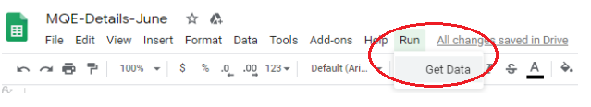

* **Output:** Select **Run  >>  Get Data.**

This will run the script and print the report for the input date range mentioned in the column B and C.

**Restrictions-**

Do not change:

* The order of the sheets in the MQE-Spreadsheet should be in the order of [Login ID, Template, CH-ID Summary, Weekly Summary, 1-Jun, 2-Jun,...]
* The name of the sheets in the Spreadsheet.
* The time or date format of any cell in the Spreadsheet.
* The structure of any sheet.

Doing any of the above-mentioned actions can cause an issue for the script to produce inaccurate results.

**Duplicate the Template sheet to create date wise sheets and rename the duplicate sheet as date followed by three letter of month name. For example, 1-Jun, 2-Jun, 3-Jun…**

Link for the Duplicate Spreadsheet: <https://docs.google.com/spreadsheets/u/1/d/1CHRlwlCynpqdy9NQaUdi_VPzEAdiIwnVWdhVwzeK2F0/edit>

**For any queries, feel free to reach at :**

1. [**kunal.singh@evelynlearning.com**](mailto:kunal.singh@evelynlearning.com)
2. [**ajay.dhiman@evelynlearning.com**](mailto:ajay.dhiman@evelynlearning.com)